**ISO 15022 Clearing & Settlement Message Flows**

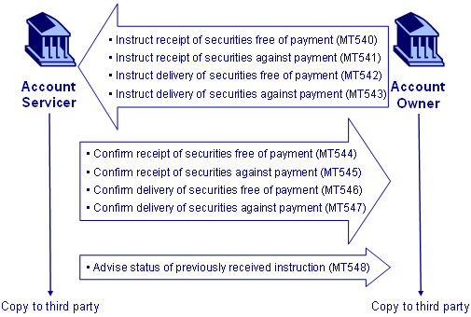

**ISO 15022 Post Trade / Pre-settlement Message Flows**

|  |
| --- |
|  |

